**Suzhou Carbon Neutral**

**Circular Development Creative Plan**

**Team Name:**

**Team Member:**

**February 12, 2022**

1. **Problem Analysis**

**1.1 Background brief**

**1.1.1 Problem introduction**

In recent years, Suzhou has faced various new problems and challenges, such as economic transformation, low coordination between low-carbon development and social progress, and increased uncertainty in economic development, which has brought impacts and challenges to the realization of the carbon neutrality goal. However, due to the influence of many factors, such as excessive reliance on foreign transfer of primary energy, insufficient resource endowment, energy consumption mainly based on traditional fossil fuels such as coal, weak development of new energy and small market share, the overall impact of Suzhou has been directly or indirectly caused the higher carbon emissions.

The following mainly deals with the processing and analysis of Suzhou's carbon emissions and other economic and environmental data in recent years, and gives a reasonable assessment of Suzhou's carbon neutrality prospects. Provide opinions and plans on resource utilization, green economy, policy system and etc, to promote environmental protection and governance in Suzhou and the Yangtze River Delta region, respond to the dual-carbon strategy, and facilitate the green and low-carbon development of the region.

**1.1.2 The scientific connotation of carbon neutralization**

Carbon peaking refers to the process in which the total amount of  emissions reaches the maximum value within a specific time interval, and then enters a stable decline stage, including three key elements: the peak-to-peak path, the peak-to-peak time, and the peak level. The carbon peak is the historical inflection point of the total  emissions from increasing to decreasing. There is also a situation where carbon dioxide emissions enter a plateau period and fluctuate within a certain range. Therefore, the realization of the carbon peak often depends on the economy to further confirm the trend of carbon emissions and make a statement. Suzhou and even my country are facing policy-driven carbon peaking, because China and other late-developing countries have advanced their climate goals such as carbon peaking and carbon neutrality, and they are facing more time and intensity than industrialized countries. To meet the emission reduction requirements, the strong intervention of the central government and the active innovation of local governments are needed to drive the realization of the carbon peaking goal with policies.

Carbon neutrality, also known as net-zero  emissions, refers to the amount of global human-induced  emissions equal to the anthropogenic  removal over a given period of time. Carbon neutrality is a concept of net value, which is not equivalent to zero emissions. The main body is not limited to countries and regions, but also includes industries, enterprises, communities and even individuals. The core is that the net emissions in the entire life cycle of economic activities and within the scope of influence are zero. Among them, factors such as population, economic development level, industrialization, urbanization level, and energy structure significantly affect the carbon emission level.

The KAYA identity establishes the relationship between human activities and population size, technological level, energy structure, and environmental regulation through mathematical analysis methods. The KAYA identity states that the level of  emissions depends on the size of the population, per capita GDP, energy consumption per unit of GDP, and carbon emissions per unit of energy consumption. Various factors are affected by technological level, environmental regulations, etc. And also act on production and consumption activities to directly or indirectly affect the emission level.

**1.1.3 The theoretical basis of research**

**1.1.3.1 Carbon Emission Estimation**

The Intergovernmental Panel on Climate Change of the United Nations has developed a general carbon emission estimation method. The carbon emission calculation expression we use is as follows:

 （1）

Among them, CE is the total carbon emission,is the impact factor,  is the corresponding source.

Through data survey, Suzhou City's carbon emissions have increased year by year in recent years.By analyzing the trend of carbon emission data in Suzhou in recent years, combined with the policies and measures of Suzhou City on carbon emissions, it is estimated that Suzhou City will reach its carbon peak in 2025.my country's overall plan is to achieve carbon peaking in 2030 and carbon neutrality in 2050. In recent years, the Suzhou Municipal Government has paid more and more attention to energy conservation, emission reduction and environmental protection. It is expected to achieve carbon peaking in 2025.

Through the analysis of the data in the table, the carbon emissions of Suzhou City have been increasing year by year in recent years, and began to decline in 2019. Considering the reality, due to the impact of the epidemic, our country's economic development has been slow or even stagnated after 2019. However, after the rapid development period of Suzhou City, the economic development has gradually stabilized, and the growth rate of GDP and carbon emissions have gradually stabilized. Its growth rate is about 4%, and it is expected to reach a carbon peak in 2025, with an estimated total carbon emission of 245 million tons.

|  |  |  |  |  |  |
| --- | --- | --- | --- | --- | --- |
| years | Total carbon emissions (gigatons) | Carbon emission growth rate (%) | GDP (trillion yuan) | GDP growth rate (%) | emissions per unit of GDP |
| 2015 | 1.6 | missing | 1.45 | missing | 1.1034 |
| 2016 | 1.7 | 6.25 | 1.55 | 6.9 | 1.0968 |
| 2017 | 1.7 | 11.8 | 1.73 | 11.61 | 1.0983 |
| 2018 | 2.06 | 8.42 | 1.85 | 6.94 | 1.1135 |
| 2019 | 2.07 | 0.49 | 1.92 | 3.78 | 1.0781 |
| 2020 | 2.02 | 2.42 | 2.02 | 5.2 | 1 |

Table (1) Suzhou Regional Gross Domestic Product (GDP) and Carbon Emissions from 2015 to 2020.

**1.1.3.2 Carbon emission intensity**

Carbon emission intensity refers to the total carbon emission (CE) caused by the growth of each unit of gross domestic product (GDP), and the expression is:

 （2）

In the formula, CI is the carbon emission intensity; CE is the carbon emission; GDP is the GDP value of the region.

Figure 1 shows the trend of carbon emission intensity calculated based on relevant GDP and carbon emissions over the years. Due to the small fluctuation of population changes in Suzhou in recent years, the population factor was not considered in the calculation of carbon emission intensity. It can be found that the carbon emission intensity per unit of GDP fluctuated to a certain extent from 2015 to 2018. It is reported that from 2018 to 2019, the carbon emission intensity exceeded the annual reduction target of 4.73%, and the growth rate was slowed down and decreased significantly after 2019.

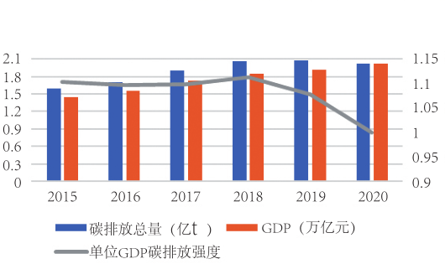

Figure (1) Carbon emission intensity per unit of GDP

**1.1.3.3 Carbon sequestration capacity of ecosystems**

The main ways of absorbing carbon dioxide in the environment are mainly divided into carbon sequestration in farmland, carbon sequestration in forest land and garden land, and carbon sequestration in other land types represented by waste grassland and reed land. The following are specific studies on the above three types of carbon sequestration pathways.

1. **Research on carbon sequestration in farmland**

The amount of carbon absorbed by various crops is equal to the organic matter produced and stored by their photosynthesis, which is the total primary productivity of crops, and the estimation of this part should also include the amount of carbon produced by crop litter and straw decay. The carbon absorption part adopts the method of calculating the biomass yield from the economic yield, and then estimating the carbon absorption amount. Because the calculation is based on economic yield, in actual consideration, the carbon released by respiration during crop growth is deducted, and this is used as the carbon absorption of the farmland ecosystem. The following mainly refers to the estimation method of Li Kerang, which uses the economic coefficients and carbon absorption rates of different types of crops to estimate the carbon absorption during the growing period of crops. The specific steps are as follows:

If the economic yield (the amount of carbon compounds collected by the crop) Y is known, the relationship between the biological yield (total dry matter) D and the economic coefficient H is as follows:

 （3）

Then the carbon uptake of the whole growth cycle of the crop is:

 （4）

1. **Research on carbon sequestration in forests and gardens**

The carbon sequestration effect of forest ecosystems depends on two opposing processes, carbon input and carbon output. The carbon input process is mainly realized by the net photosynthesis of forest plants, and the carbon output process mainly refers to the heterotrophic respiration process of forest ridge soil and animals and the mineralization process of litter. The research on the biomass and net production of forest vegetation in China shows that the dry matter production of different vegetation varies greatly, and its range is between 0.11 and 0.14. The following table shows the carbon sequestration of various ecosystems in Suzhou from 1997 to 2005:

Table (2) Carbon sequestration of various ecosystems in Suzhou from 1997 to 2005

unit: 

|  |  |  |  |  |  |  |  |  |  |
| --- | --- | --- | --- | --- | --- | --- | --- | --- | --- |
| type of land | 1997 | 1998 | 1999 | 2000 | 2001 | 2002 | 2003 | 2004 | 2005 |
| arable land | 309.37 | 253.93 | 251.82 | 220.78 | 180.39 | 161.39 | 125.99 | 131.96 | 124.79 |
| woodland | 4.79 | 4.82 | 4.81 | 4.81 | 4.8 | 4.93 | 4.92 | 5.08 | 5.08 |
| garden | 9.98 | 9.96 | 9.83 | 9.78 | 9.71 | 9.38 | 9.29 | 10.21 | 10.84 |
| Urban Green Space | 1.26 | 1.29 | 1.42 | 1.61 | 1.73 | 1.94 | 2.24 | 2.52 | 2.81 |
| other land types | 28.51 | 28.45 | 28.30 | 28.28 | 28.17 | 30.44 | 30.10 | 30.62 | 30.67 |
| total | 353.91 | 298.45 | 296.18 | 265.26 | 224.80 | 208.08 | 172.54 | 180.39 | 174.19 |
| difference | - | -55.46 | -57.73 | -88.65 | -129.11 | -145.83 | -181.37 | -173.52 | -179.72 |

In land classification, forest land is divided into forest land, shrub land, sparse forest land, unforested afforestation land, and nursery land. Among them, the traced land is the type of land that has not been renewed within 5 years after deforestation or fire, and is not considered in the calculation. According to the research of relevant scholars, the annual primary net production of forest land in Jiangsu Province is 9.84t/h,The annual primary net production of open forest land and shrub land is 10.95t/h; Unforested afforestation land refers to newly afforestation land whose survival rate is greater than or equal to 41% of reasonable afforestation, and its annual net primary production is calculated as 41% of the forest land, which is 4.49t/h; The annual net primary production of the nursery, calculated as shrub land, is 10.95t/h.

Considering that the Suzhou gardens are mainly orchards, mulberry orchards and tea gardens, the carbon sequestration capacity is considered to be the same as that of the woodlands in the calculation.

Urban green space includes public green space, protection and production green space, and has important ecological value. According to related research from 1997 to 2005, we take the annual carbon uptake per hectare of green space as 5.99t.

1. **Research on carbon sequestration by other land types**

Such lands with carbon sequestration functions include reeds, tidal flats, barren grasslands, swamps, and water systems such as lakes and rivers with aquatic plants. Based on the research on the surface ecological conditions of the above various types of land and the research of Zhu Qinghai et al., we take the annual net primary production of barren grassland as 10% of the shrub forest land, which means that 1.10t/h.

The carbon sequestration rate of lakes, rivers and other water systems is taken as 5-72g/; The density of reeds in Suzhou area is roughly 1.57 106 plants/h; The net growth of a single plant is 6.37g/(plant a), Therefore, the annual growth of the reed field, that is, the carbon sequestration amount is 10.00t/h; According to the research of Aselmann et al., we take the annual net primary production of swamp and tidal flat vegetation in Suzhou as 15.00t/h.

**1.1.3.4 Calculation of carbon emissions**

Standard coal is also known as coal equivalent, which has a unified calorific value standard. my country stipulates that the calorific value of standard coal per kilogram is 7000 kcal (29307.6 kJ). There are many types of energy sources, and the heat they contain is also different. In order to facilitate mutual comparison and research on the total amount, we often convert various energy sources into standard coal to express. The following table shows the reference coefficients of converted standard coal for commonly used energy and most externally transferred primary energy in Suzhou:

Table (3) Standard coal reference coefficient table for conversion of commonly used energy and most externally transferred primary energy in Suzhou

|  |  |  |  |
| --- | --- | --- | --- |
| Energy serial number | energy category | Average low calorific value (kJ/kg) | Converted standard coal coefficient |
| 1 | raw coal | 20934 | 0.7143 |
| 2 | Clean coal | 26377 | 0.9000 |
| 3 | Coal washing slime | 8374 | 0.2857 |
| 4 | coke | 28470 | 0.9714 |
| 5 | crude | 41868 | 1.4286 |
| 6 | fuel oil | 41868 | 1.4286 |
| 7 | gasoline | 43124 | 1.4714 |
| 8 | kerosene | 43124 | 1.4714 |
| 9 | diesel fuel | 42705 | 1.4571 |
| 10 | liquefied petroleum gas | 47472 | 1.6198 |
| 11 | natural gas | 35588 | 1.2143 |
| 12 | coke oven gas | 16746 | 0.5714 |
| 13 | other gas | 10463 | 0.3570 |

According to the statistics of experts, the following table shows the emission coefficient of using 1 kilowatt-hour (kWh) of electricity:

Table (4) Emission coefficient using 1 degree point (unit: kg)

|  |  |  |  |  |
| --- | --- | --- | --- | --- |
| Converted standard coal | carbon emission | carbon dioxide emissions | Sulfur dioxide emissions | NOx emissions |
| 0.4 | 0.272 | 0.997 | 0.03 | 0.015 |

According to the information provided by BP China Carbon Emission Calculator, the carbon dioxide and carbon emission factors of using gasoline or diesel or coal (converted to standard coal) are shown in the table below:

Table (5) Carbon emission data of several fossil energy sources

|  |  |  |  |  |
| --- | --- | --- | --- | --- |
| energy name | emission factor |  | carbon emission factor |  |
| - | kg/liter | kg/kg | kg/liter | kg/kg |
| gasoline | 2.30 | 3.15 | 0.627 | 0.86 |
| diesel fuel | 2.63 | 3.06 | 0.717 | 0.834 |
| standard coal | - | 2.493 | - | 0.68 |

The following table shows the density of several liquid energy sources:

Table (6) Densities of several liquid energy sources

|  |  |  |  |  |  |
| --- | --- | --- | --- | --- | --- |
|  | crude | gasoline | kerosene | Light diesel oil | distilled spirits |
| Density (kg/ liter) | 0.87 | 0.73 | 0.82 | 0.86 | 0.912 |

**2. Policy entry points for carbon neutrality**

**2.1 Sustainable economic development**

Because carbon peaking is a staged phenomenon of economic and social development, carbon emissions show the peaking sequence of intensity, per capita, and total amount, and the peaking of total energy consumption mostly occurs after the peaking of carbon emissions. Especially industrialization and urbanization are important causes of  emissions. Therefore, it is particularly important to find a carbon-neutral path for sustainable development that meets the needs of the present without compromising the development potential of future generations. The traditional "pollution first and then treatment" is the economic and social development path under the weak sustainability model. Therefore, we should adhere to the concept that man-made capital and natural capital can replace each other, reduce the dependence on traditional energy sources such as fossil energy,improve the anti-strike carrying capacity of the atmosphere, land, lakes and rivers and other ecological environment systems, and try to avoid the overload of environmental resources in the past. A rough, primitive idea of ​​economic development to boost the economy at the expense. The following table shows the economic and carbon emission related data of Suzhou in recent years:

Table (7) Suzhou's economic and carbon emissions data in recent years

|  |  |  |  |  |  |
| --- | --- | --- | --- | --- | --- |
| years | Total carbon emissions (gigatons) | Carbon emission growth rate (%) | GDP (trillion yuan) | GDP growth rate (%) | emissions per unit of GDP |
| 2015 | 1.6 | - | 1.45 | - | 1.1034 |
| 2016 | 1.7 | 6.25 | 1.55 | 6.9 | 1.0968 |
| 2017 | 1.9 | 11.8 | 1.73 | 11.61 | 1.0983 |
| 2018 | 2.06 | 8.42 | 1.85 | 6.94 | 1.1135 |
| 2019 | 2.07 | 0.49 | 1.92 | 3.78 | 1.0781 |
| 2020 | 2.02 | 2.42 | 2.02 | 5.2 | 1 |

It can be seen that since 2015, the GDP of Suzhou region has maintained a steady growth, and has basically maintained a growth rate of more than 6% until 2018. In the past two years, due to economic transformation, the growth rate has slowed down until the GDP exceeds the 2 trillion mark in 2020. Similarly, the total amount of carbon emissions in Suzhou also increases with the growth of the economy. The following picture shows the carbon emissions data of Suzhou from 2015 to 2020:

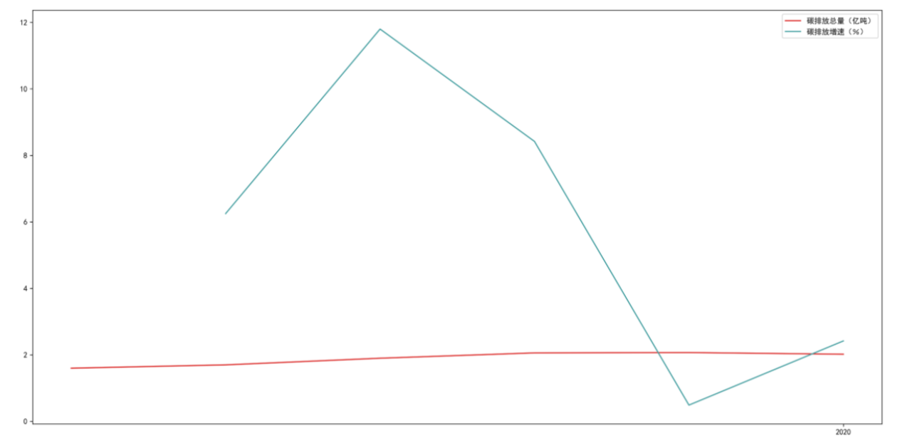

Figure (2) Suzhou's carbon emission data map from 2015 to 2020

The figure shows that the carbon emissions in Suzhou also maintained a positive correlation growth rate from 2015 to 2018. In 2019, it began to slow down, and in 2020, there was a negative growth, and its carbon emissions showed a downward trend for the first time.

In order to analyze the impact of economic growth on carbon emissions, we make the following economic data map of Suzhou:

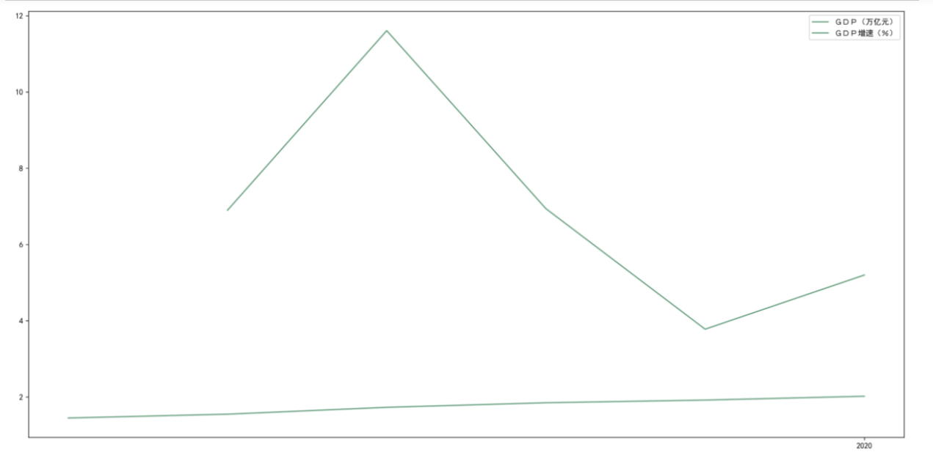

Figure (3) Suzhou GDP data map from 2015 to 2020

It can be seen that the growth of GDP in Suzhou is highly similar to the growth of carbon emissions. It can also be seen from Table (7) that the carbon emission intensity per unit of GDP fluctuated to a certain extent from 2015 to 2018. It is reported that the carbon emission intensity in 2018-2019 exceeded the annual reduction target of 4.73%, the growth rate slowed down, and decreased significantly after 2019. It can be basically judged that the Suzhou area has reached its peak.

In the future, Suzhou area should adhere to the principle of irreducible natural capital under the sustainable development framework of "environment-society-economy" inclusive relationship, and adjust the structure of natural capital, human capital and other element capital to keep it within a relatively reasonable range.

**3. Entry point of the energy route for carbon neutrality**

**3.1 Current situation of energy in Suzhou**

The energy problems faced by this region are mainly due to the over-reliance on foreign transfer of primary energy, insufficient resource endowment, energy consumption mostly dominated by traditional fossil fuels such as coal, weak development of new energy and small market share. Key energy figures for 2020:

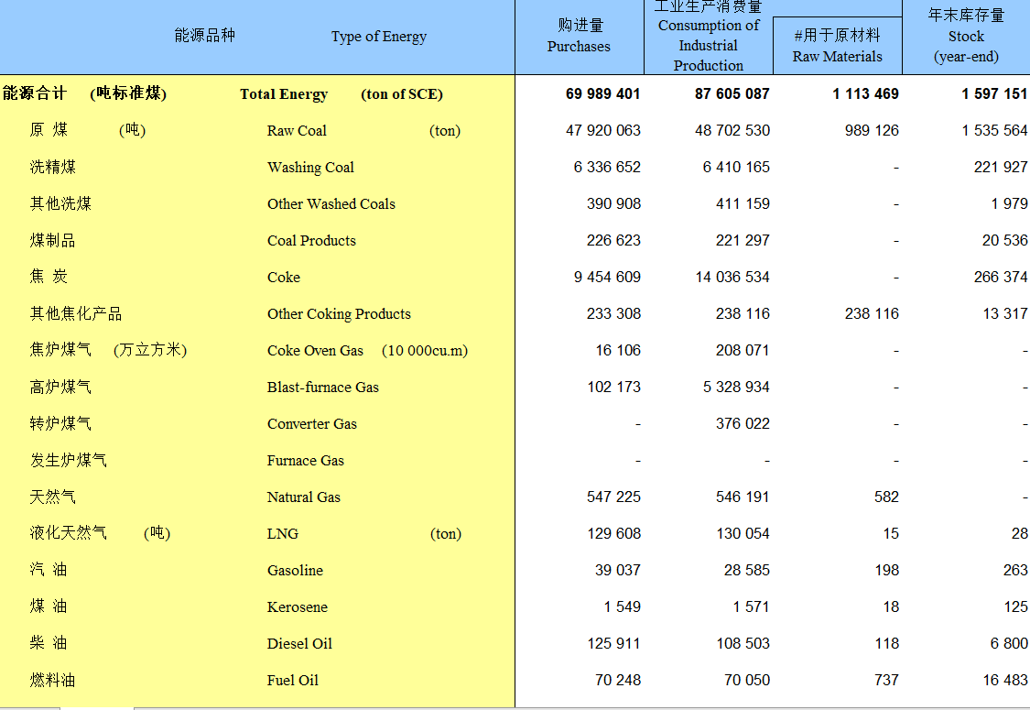

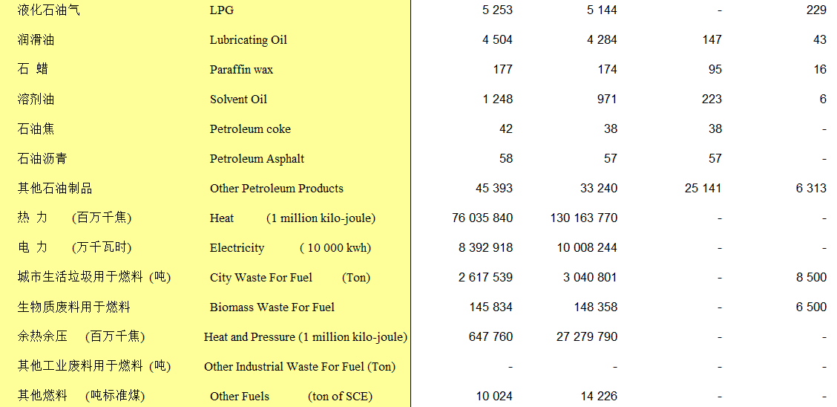

Figure (4) The main energy data map of Suzhou in 2020

It can be seen that the main energy consumption in Suzhou is divided into several categories: raw coal, coke, electricity, and the city's electricity consumption. According to the converted carbon emission data of various energy sources given in 1.1.3.4, it is calculated that the carbon emissions caused by the consumption of the above various types of energy are 24000869.72, 9408211.73, 27222424985.60, and 41434848000kgC, respectively. (The above calculation includes carbon emissions from coal consumption in power plants, and carbon emissions from cars are considered as gasoline and diesel consumption). The following picture shows the data of motor vehicles in Suzhou in 2020:

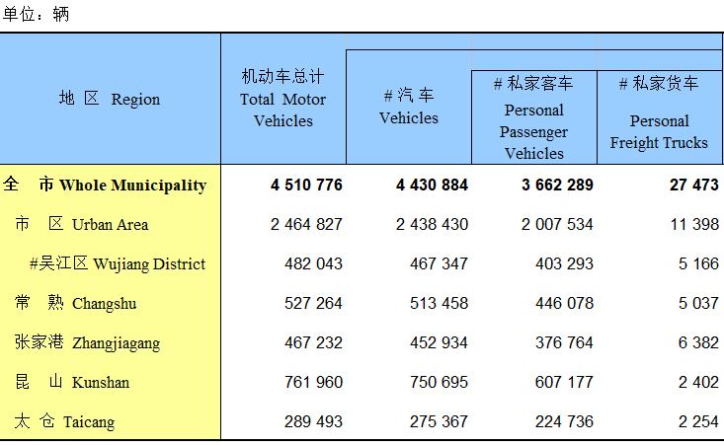

Figure (5) Suzhou Motor Vehicle Data by Region in 2020

It can be seen that Suzhou's large base of use of traditional fossil energy is an important reason for the high carbon emissions in the region.

**3.2 Ideas for energy improvement**

The fundamental problem of carbon neutralization is the energy problem. The development of renewable energy through a high proportion is the key to stripping the relationship between economic development, energy consumption and carbon emissions. Suzhou is rich in renewable resources, but the development and application of renewable energy are restricted by factors such as technical defects and unbalanced system allocation. Various links of construction, industry, transportation, production and life have established extensive and complex connections through the coordination of energy and power systems. Therefore, comprehensively considering energy security, economic development, carbon emission levels and other aspects, promoting the diversification, low carbonization and intelligence of the energy system should be the current mainstream of development. Here are a few specific ideas to guide:

1. Help colleges and universities to speed up research on high-efficiency solar photovoltaic technology, independently develop core equipment and components, and establish a complete technical system. Research and develop high-efficiency and low-cost laminated solar cells and component systems, focusing on solving the heat dissipation problem of traditional concentrating photovoltaic power generation systems and reducing photovoltaic power generation costs.
2. Accelerate the research and research on renewable energy hydrogen production technology and water electrolysis hydrogen production membrane electrode preparation technology, and strive to realize the storage and transportation of large quantities of hydrogen in the form of liquid stable compounds as soon as possible.
3. Vigorously support the recycling technology of waste resources, especially the recycling technology of cyanobacteria and algae mud and the technology of comprehensive utilization of forestry, straw and other resources.
4. Focusing on the practical problems of complex sources of solid waste, large amount of production, and difficult disposal, carry out research on the utilization of negative carbon resources for industrial solid waste and urban solid waste.

**4. Carbon sequestration potential of Suzhou ecosystem**

**4.1 Overview of Suzhou Forest Green Space Resources**

The land area of ​​Suzhou City is 848,782.6 hectares, accounting for 7.95% of the total land area of ​​Jiangsu Province. Among them, agricultural land is 366,650.6 hectares, accounting for 43.20% of the city's total land area; construction land is 166,990.2 hectares, accounting for 19.70%; other land is 315,141.8 hectares, accounting for 37.10%; among the agricultural land, arable land is 245,345.3 hectares, accounting for 66.92% of the agricultural land; garden land is 24,773.3 hectares, accounting for 6.76% of agricultural land; 11,248.1 hectares of forest land, accounting for 3.07% of agricultural land; a small amount of pasture, only 0.2 hectares; 85,283.7 hectares of other agricultural land, accounting for 23.26% of agricultural land; construction land, urban and rural construction 149,827.5 hectares of land are used, accounting for 89.72% of the construction land; 15,345.7 hectares of land for transportation and water use, accounting for 9.19% of the construction land; 1,817.0 hectares of other construction land, accounting for 1.09% of the construction land. Among other lands, water area is 307,867.3 hectares, accounting for 97.69% of other lands; natural reserves are 7,274.5 hectares, accounting for 2.31% of other lands.

Suzhou City is located in the north subtropical humid monsoon climate zone. The climate is warm and humid, the land is fertile, the monsoon is obvious, the four seasons are distinct, and the precipitation is abundant. By referring to the investigation and research on the vegetation types of Suzhou green space by relevant scholars, the vegetation types of Suzhou green space are obtained as shown in the following figure: (the vertical axis unit in the figure is: species)

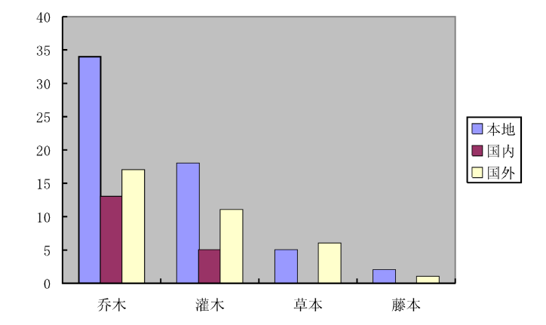

Figure (6) Distribution of main plant categories in Suzhou City

The figure is a comparison of the carbon fixation and oxygen release capacity of different life forms of related plants:

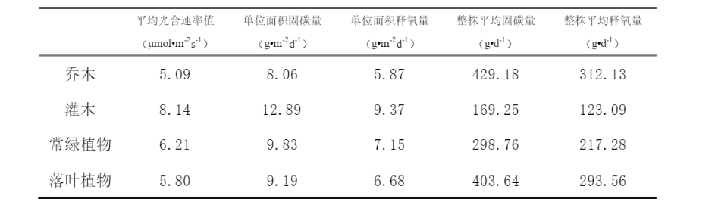

Figure (7) Carbon fixation and oxygen release capacity of plants with different life forms

Based on the mainstream plant species in the figure, through the calculation method given in 1.1.3.3 and the Suzhou forest resource data given above, we calculated the carbon sequestration data of Suzhou in 2020 as follows:

Table (8) Suzhou's carbon sequestration data in 2020

|  |  |  |  |
| --- | --- | --- | --- |
|  | unit carbon uptake | area | total carbon uptake |
| arable land | 5.09 | 245345 | 1248806.05 |
| garden | 5.99 | 24773 | 148390.27 |
| woodland | 4.49 | 11248 | 50503.52 |
| other land types | 1.1 | 85283 | 93811.3 |
| grassland | 0 | 0.2 | treated as 0 |
| Unit/Total | tons/ hectare | hectare | 1541511.14 |

**4.2 Analysis of carbon sequestration potential in Suzhou**

**4.2.1 Carbon neutralization pathway analysis**

"Carbon absorption", that is, to solidify and store greenhouse gases such as free carbon dioxide through technical means. To try to reduce the carbon stock in the atmosphere, there are currently two main development models to achieve carbon neutrality: carbon emission reduction and carbon absorption.

**1."Carbon emission reduction": little possibility of short-term breakthrough**

In the world, coal and oil are still the main energy sources, and the current technical strength is still unable to achieve the emission reduction target quickly, and the current low-carbon economy advocated by the country mainly aims to reduce carbon dioxide emissions, including thermal power, automobiles, buildings, etc. , industrial emission reduction, and circular economy and energy-saving materials. According to a survey by Zero2IPO Research Center, this year, my country's clean technology market investment may exceed 2 billion US dollars, and the new energy industry and water/sewage treatment industry may become investment hotspots in the clean energy industry this year.

However, correspondingly, despite the booming investment in the "carbon emission reduction" industry, at this stage, even developed countries are still groping for the future development direction of new energy standards. Still taking new energy vehicles (EV vehicles) as an example, the goal is to use vehicle battery technology to provide power, thereby completely getting rid of the dependence on oil. But the current problem is that the standards for new energy vehicle batteries are still being formulated. Positive and negative materials, battery pack connection technology and management units, as well as battery capacity and discharge power, especially safety standards, are all being formulated.

Therefore, in the next three years, experts estimate that it will be difficult for new energy vehicles to achieve rapid development and promotion. Currently, hybrid vehicles are still used as the mainstream of development in the world. This also shows that "carbon emission reduction" is a relatively long-term task under the current energy consumption structure.

**2. "Carbon sequestration": Forest carbon sinks are better than carbon capture (CCS)**

In layman's terms, carbon capture (CCS) is to capture carbon dioxide before it is emitted, then transport it to a storage site through pipelines or ships, and finally compress it and inject it into the ground to achieve the purpose of complete emission reduction. Under the background that climate change has become a public topic, and European and American politicians believe that the energy consumption pattern dominated by coal will not change in the short term, CCS seems to be an inevitable choice for carbon dioxide control.

**4.2.2 Suzhou's existing planning**

**1. Expand the area of ​​green space - promote carbon absorption**

In order to further strengthen the protection and construction of Suzhou's green space ecosystem and promote the high-quality development of Suzhou's ecological civilization construction, under the unified deployment of the Municipal Party Committee and Municipal Government, the Municipal Landscaping Bureau launched the "Suzhou Urban Green Space System Planning (2017-2035") at the end of 2017.)", during the planning process, the Municipal Landscaping Bureau carried out in-depth research on the current situation of urban green space, and fully connected with the district and county departments to implement basic data. At the same time, the Municipal Landscaping Bureau fully connects with the Municipal Planning and Natural Resources Bureau, the China Planning Institute and other departments, maintains information exchange with higher-level plans such as the master plan, and ensures that the core management and control content is included in the master plan.

At present, the "Suzhou Urban Green Space System Planning (2017-2035)" has officially passed the expert review. Experts agreed that the "Suzhou Urban Green Space System Planning (2017-2035)" formed the "two belts and one core, four rings and four wedges" planning structure and the Jiangnan characteristics of "waterfront green network ecological corridor system", which emphasized the importance of Suzhou. The protection of the overall ecological ring, ecological corridors and the "four-cornered landscape" of Suzhou city, the planning research is in-depth, the analysis is detailed, the objectives are clear, the system is standardized, and the requirements for the preparation of the special planning are basically met. The Municipal Landscaping Bureau will lead the layout and construction of the urban green space system through planning, highlight the characteristics and highlights, and carefully draw a magnificent blueprint for Suzhou's greening construction with higher standards and more scientific concepts, so as to build Suzhou into a green city that everyone yearns for Ecological City, Garden City.

The first planning strategy of the "Suzhou Urban Green Space System Planning (2017-2035)" is "green sharing, public participation", building a characteristic urban park system, continuing to build large green spaces, and continuously promoting the free opening of various green spaces.

The second is to increase the per capita park green space and put forward rigid control indicators. By 2020, the per capita park green space will be increased from the current 14.5 square meters to 15 square meters, and by 2035 to 15.5 square meters, that is, everyone has 15 square meters. meters of park green space, and effectively enhance the sense of acquisition and happiness of the general public.

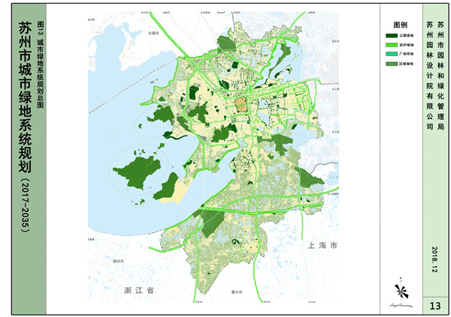

**Figure (8) Suzhou urban green space planning**

**2. Leading by science and technology, energy saving and emission reduction - promoting carbon emission reduction**

According to "Suzhou Daily" report: Suzhou is designing and planning the carbon emission peak target and realization path, striving to ensure that the overall carbon peak can be achieved by 2030 at the end of the "14th Five-Year Plan". It will create a new green and low-carbon growth point by cultivating low-carbon leading backbone enterprises and guiding innovation elements to agglomerate in enterprises. The main means are:

1. **Innovative practice of a "zero carbon factory"**

All the electricity used in the factory comes from solar energy, wind power and biomass energy; the sewage is reused after advanced treatment, so that 40% of the water resources required for production can be recycled... Suzhou Shangmei's "zero carbon" construction is undoubtedly the first step.

1. **Comprehensive energy stations gradually become a breakthrough**

At the beginning of this year, one of the first batch of comprehensive energy demonstration station projects in Jiangsu Power Grid, Suzhou 110 kV Xiangshan Comprehensive Energy Station was completed and put into operation. The station is the first comprehensive energy station in Suzhou that integrates wind, solar, charging and substations. It is estimated that the annual power generation of photovoltaics and wind turbines will be 42.53 MWh, which is equivalent to reducing carbon emissions by 11.56 tons. At the same time, the charging pile system provides convenience for green travel, and provides a variety of auxiliary services in the station to realize the autonomous operation of equipment in the station and the mode of remote control and management.

1. **Accelerate the adjustment of the energy structure**

The main source of carbon emissions in Jiangsu Province is the consumption of fossil energy, of which electricity is one of the main industries of carbon emissions. In Jiangsu, greenhouse gas emissions and atmospheric pollutant emissions have the same origin, which determines the synergistic effect of air pollution control and climate change in target measures. Jiangsu's energy activities generate carbon emissions as high as 93.7%. In order to achieve the goal of carbon peaking ahead of schedule, it is necessary to vigorously promote the reform of energy structure. In addition to promoting the adjustment of energy structure, energy efficiency must continue to be improved.

The first is to improve the standard formulation of carbon emissions, and the second is to continuously reduce the energy consumption per unit of regional GDP and effectively improve the energy efficiency utilization level of the industry. Suzhou is a major industrial city with the highest total energy consumption in the province. It is also a national low-carbon pilot city. Therefore, it is very important for Suzhou to simultaneously develop the economy and reduce carbon emissions.

**4.2.3 Estimation of Suzhou Carbon Absorption Capacity**

According to the strategy of "Suzhou Urban Green Space System Planning (2017-2035)", the first is to build a characteristic urban park system, continue to build large-scale green spaces, and continuously promote the free opening of various green spaces. The second is to increase the per capita park green space, and put forward rigid control indicators. By 2020, the per capita park green space will be built, from the current 14.5 square meters to 15 square meters, and to 15.5 square meters by 2035.

Our team used the population trend of Suzhou to predict the population of Suzhou in 2035, and estimated the green area of ​​Suzhou in 2035 according to the development plan.

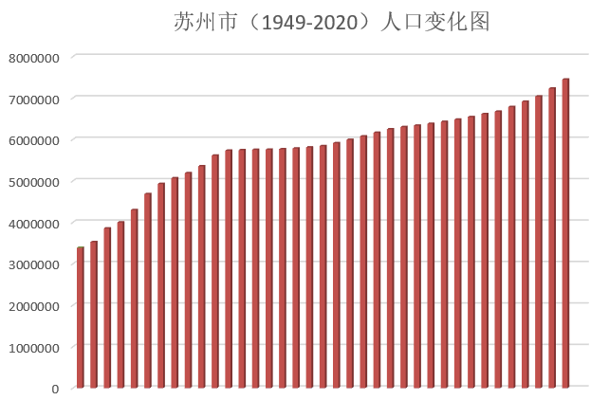

Figure (9) Suzhou Population Change Map

It is predicted that the population of Suzhou in 2035 will be about 7.8 million. According to the urban green space planning, by 2035, the area of ​​green space in Suzhou will be about 26,000 hectares, and the carbon absorption capacity will be about 1.56 million tons.

Through analysis, it is found that only by increasing the area of ​​green space to improve carbon absorption capacity has little effect on promoting carbon neutrality.

1. Construction of a carbon neutral system in Suzhou

Through analysis, our team predicts that Suzhou City will reach its carbon peak in 2025, and envisage that Suzhou City will achieve its carbon neutrality goal from 2035 to 2045. In order to achieve this goal, our team recommends the following Suzhou cities to start in the following areas.

1. **Traffic system adjustment.**

Suzhou currently fully implements the "National VI" motor vehicle emission standards.Strengthen the construction of urban public transportation system, promote the promotion of new energy vehicles, gradually replace fuel vehicles, reduce the consumption of gasoline and diesel, and directly reduce exhaust emissions.

1. **Energy structure adjustment.**

Suzhou held a hydrogen energy industry development work promotion meeting. Suzhou hydrogen energy and fuel cell industry development plan and hydrogen energy industry development white paper were officially released. By 2035, Suzhou hydrogen energy and fuel cell industry will exceed 100 billion yuan in output value, and Suzhou will become a highland for the hydrogen energy and fuel cell industry with global influence.

Promote the utilization of hydrogen energy, solar energy, wind energy, nuclear energy, etc., gradually reduce the dependence on non-renewable energy, reduce the proportion of thermal power in the total power generation, and reduce the dependence on traditional fossil energy such as coal.

1. **Improve energy utilization.**

Promote the construction of a "zero carbon factory", upgrade the internal process technology of the factory, optimize the process flow, reduce energy consumption and waste, and carry out rectification and limit emissions for enterprises with large carbon emissions, and for enterprises with excessive pollution , migrate or shut down gradually.